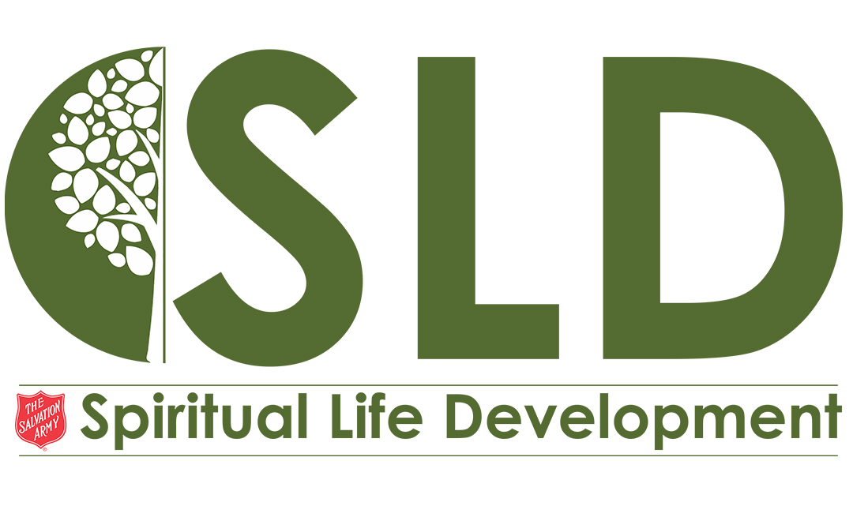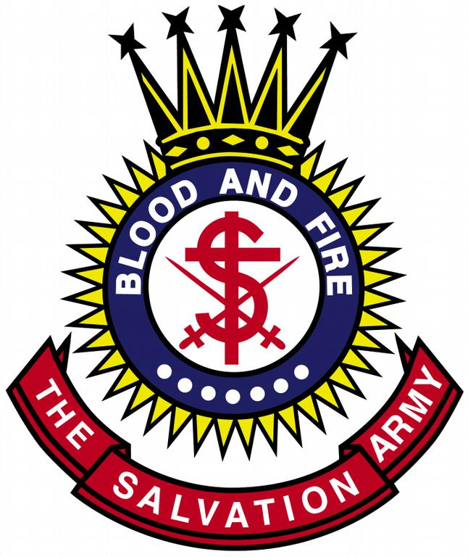Holiness Institute for Soldiers

September 21-24, 2017

**“…On Things Above” (Colossians 3:1-4)**

The Salvation Army USA Eastern Territory

5/12/17

Crestview Conference Center

West Nyack, NY

**\*COMPLETED AND APPROVED APPLICATION MUST BE RECEIVED BY SPIRITUAL LIFE DEVELOPMENT AT THQ BY AUGUST 1, 2017 TO QUALIFY FOR THE EARLY BIRD PRICING.**

**\*DEADLINE FOR HOLINESS INSTITUTE APPLICATION IS – September 1, 2017**

**Registration Fee: Early Bird ($150) or Standard ($200)**

* This includes arrangements for lodging, made by the SLD Department, from Thursday, September 21- Sunday, September 24, 2017 (morning check-out).
* Breakfast (at the Hotel), Lunch & Dinner (Conference Center)
* Materials provided for all class activities
* If your spouse is attending Holiness Institute, he/she must submit a separate application for approval.

|  |  |
| --- | --- |
| Gender: M  F Age: | My spouse is attending Holiness Insitute  Spouse’s Name: |

|  |  |
| --- | --- |
| **First Name:** | **Last Name:** |

|  |
| --- |
| Mailing Address: |

|  |  |  |
| --- | --- | --- |
| City: | State: | Zip: |

|  |  |
| --- | --- |
| Home Tel. Number: | Cell Number: |

|  |
| --- |
| E-mail address: |

|  |  |
| --- | --- |
| Corps/ARC: | Division: |

|  |  |
| --- | --- |
| **Emergency Contact:**  Full Name: | Phone Number: |

|  |
| --- |
| **Status of Delegate** (Choose One):  Corps Local Officer  Soldier Adherent  Other  If other, please explain:  **Preferred Language** (Choose One):  English  Spanish  (limited Spanish translation available upon request) |

|  |
| --- |
| **Please fill out the questions below:**  List any special dietary needs or medical considerations:  How long have you been associated with your Corps/ARC:  Please list all activities that you are actively involved with at your Corps/ARC: |

**Please follow the instructions below:**

**DELEGATE** – Please email this completed form to your Corps/ARC Officer for his/her approval.

**CORPS/ARC OFFICER** – Once you receive a completed application form, please type/print your name indicating your recommendation. Please forward the application via e-mail to your Command Head for final approval.

**COMMAND HEAD** – Once you have received Delegate application(s) from Corps/ARC Officers with their recommendations, please type/print your name indicating your approval. Please forward completed applications via e-mail to the Territorial Ambassador for Holiness, Major Young Sung Kim, and copy Miosotis Hernandez NO LATER THAN **September 1, 2017.**

**\***We will **ONLY** accept application forms coming from the Command Head.

**PAYMENT INFO**

Completed and approved applications must be received by **Spiritual Life Development** at THQ by **August 1, 2017** to qualify for the EARLY BIRD PRICING ($150). The deadline for standard registration is **September 1, 2017**, and registration fees increase to $200. Please submit payment upon approval of your application. **Lodging arrangements are not guaranteed until payment is received.**

Please contact **Miosotis Hernandez** if you have any questions or need assistance.

[Miosotis.Hernandez@use.salvationary.org](mailto:Miosotis.Hernandez@use.salvationary.org) p:(**845) 620-7676**

**OFFICIAL USE ONLY**

|  |  |
| --- | --- |
| **Corps/ARC Officer Recommendation**  Recommended by  Type Name Here:  Type Name here: | **Command Head Endorsement**  Approved by  Type Name Here:  Type Name here: |

Top of Form

Bottom of Form

Major Young Sung Kim

Territorial Ambassador for Holiness

[YoungSung.Kim@use.salvationarmy.org](mailto:YoungSung.Kim@use.salvationarmy.org)

**The Salvation Army**

**USA Eastern Territory**

The Office of Ambassador for Holiness

440 West Nyack Road

West Nyack, NY 10994-1739